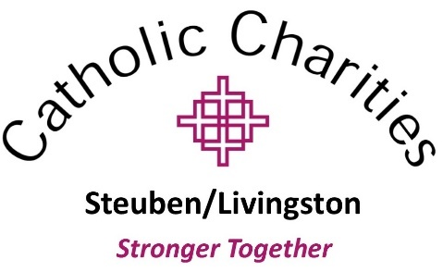

For Immediate Release
October 20, 2020

Catholic Charities of Steuben and Catholic Charities of Livingston County to Merge January 1st. Combined Efforts Will Allow Catholic Charities to Serve More Than 30,000 People Per Year.
The Board of Directors of Catholic Charities of Steuben and Catholic Charities of Livingston County announces that the two non-profit agencies will merge effective January 1, 2021. The new organization will be called Catholic Charities Steuben/Livingston and will be run by the current CEO, Tabitha Brewster, Ph.D.. According to Brewster, “As a larger organization with broader geographical reach, the new agency will be able increase the stability of our government funding. As a community organization, we focus all our efforts and decisions on how we can better serve the community. Now, we will have the ability to support our communities and provide them with the best possible services, while increasing our capacity and expertise. We have already begun to achieve financial efficiencies through a joint CEO and by streamlining expenses.”
All current services and programs available to clients in both counties will continue and they will also continue to maintain their independent office locations in Steuben and Livingston County. All donations and funding that is earmarked for either Steuben or Livingston counties will remain in that county as well. In addition, they will continue the practice of honoring donor requests with systems built to accommodate and track that information.
Catholic Charities services empower people to enrich their quality of life from the foundations of: access to basic needs services including financial assistance to avoid homelessness, food pantries, healthcare counseling, access to resources and employment training; healthy family functioning; healthy child development, and freedom from substance use. Adds Brewster, “By integrating our two organizations we can deliver better outcomes for our clients, funders, and staff”.
No one will lose employment with Catholic Charities as a result of the integration of the two organizations and the goal is to invest in people equally and to retain talent.
From October to December the organization will be working to develop the systems and policies to support the combined operations as of January 1, 2021.

For any questions, please contact Tabitha Brewster, CEO, Catholic Charities of Steuben/Catholic Charities of Livingston County at Tabitha.Brewster@dor.org.

###
Catholic Charities Steuben/Livingston mission is to build communities that care for all people by strengthening and enriching the quality of life for individuals, families, and children; working to reduce poverty; and advocating for social justice. For more information and a complete list of services by county, please visit CatholicCharitiesSteuben.org and aboutcclc.org

